Lab 10 – for loops
In this lab you’ll be using for loops to perform various calculations. In parts (a) and (b) of the lab, the counting variable will be used as part of the calculation inside the for loop. For parts (c) and (d) the counting variable will be used purely for counting and not as part of the calculations. Submit a single .cpp file with the solutions to all four parts in main().

Lab 10a
Use a for loop to loop through the values 10, 20, 30 … 100. Each time through the loop, display the number of miles and its equivalent in kilometers.
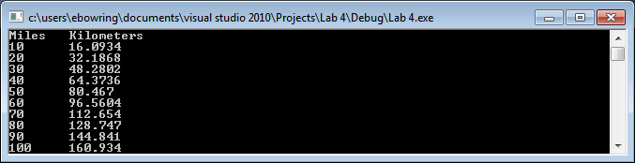

Lab 10b
Use a for loop to loop through the numbers 97, 98, 99 … 122. Display the number and then typecast it to a character and display the character whose ASCII code is the number you just displayed.
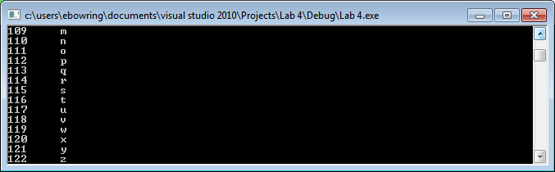

Lab 10c
Use a for loop to simulate the addition of interest to a savings account. Ask the user for an account balance, interest rate and number of years. Then loop as many times as specified by the number of years. Each time through the loop, update the account balance with an additional year’s worth of interest.
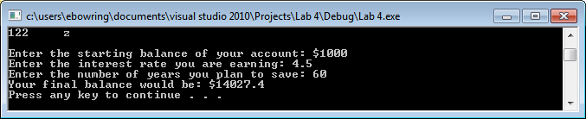

Lab 10d
Use a for loop to generate 10 random math problems. Choose two random numbers between 1 and 100 and then randomly choose whether the user should add, subtract or multiply the numbers. To choose an operation randomly, generate one of three random numbers (e.g. 1 … 3), then if the computer chooses 1, you can treat that as add, etc. As shown in the output below, have the user type in what they think is the answer to each problem (what is after the = in the output below). Then, tell the user if they are correct or incorrect.
